Movies Manager Application Project Status Report

Sintayow Asefa

April 27, 2021

Table of Contents

Executive Summary 2

Accomplishment 2

Focuses 5

Roadblocks 6

References 7

# Executive Summary

This Movie Manager Status report outlines all about the Movie manager application in terms of I have been able to accomplish throughout the development effort this includes all the key area which I worked on especially on the Coding part of the project and the roadblocks experienced. In this Project C, I Worked on the database development, as well as coding of all the application such as add, update and delete form using C# winform and visual studio.

# Accomplishment

In the project C I have been able to accomplish several things using C# informs. From the second part of the project.

1. Designing of the project manager main form including the data grid view and the menus items, in additional I had to code the datagridview to populate and refresh the data.
2. Coding of the add movie form functionalities using C# language and the MySQL database.
3. Coding of the update movie form functionalities using C# language and the MySQL database.
4. Coding of the delete movie form functionalities using C# language and the MySQL database.
5. Application design – The interface remained the same but the functionalities had been updated.

* Main Form (main.cs)
* This is the main form or the application dashboard where every form can be accessed.
* 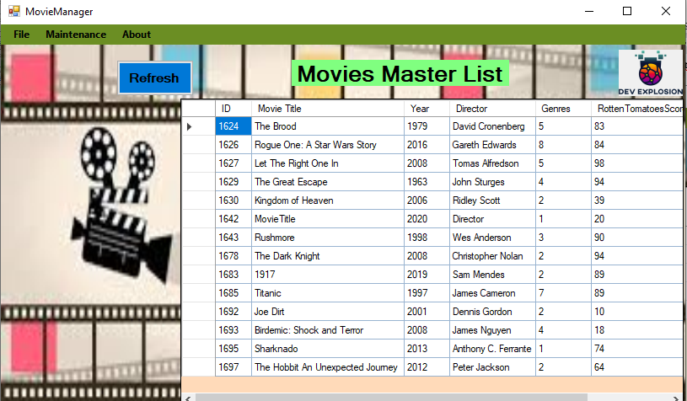

Add Movie Form

This form enables the application admin to add new movie for listing

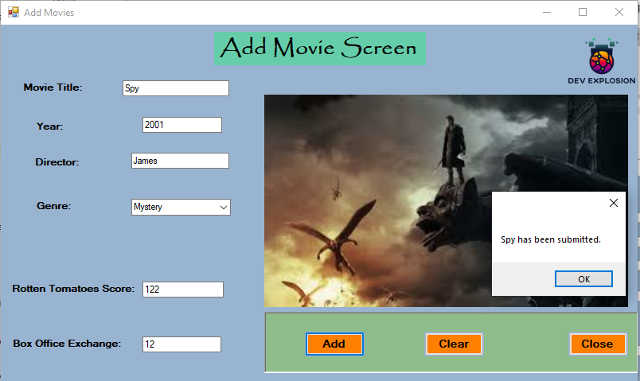

Update Form

This Movie Manager Application Form enables the user to edit the movie details then update.

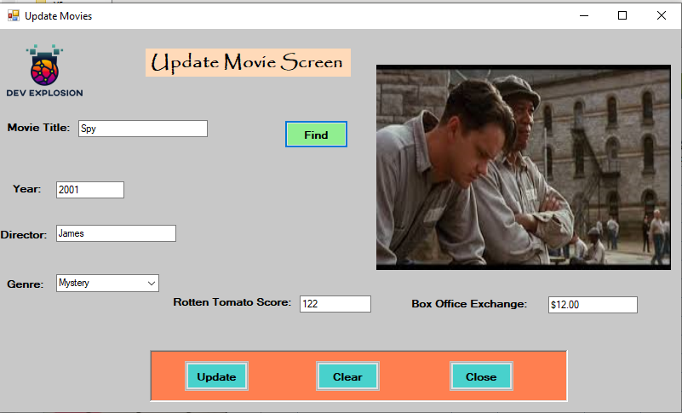

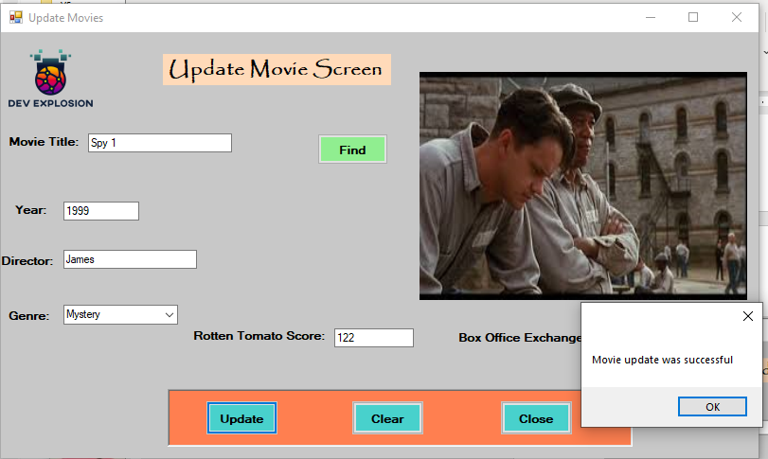

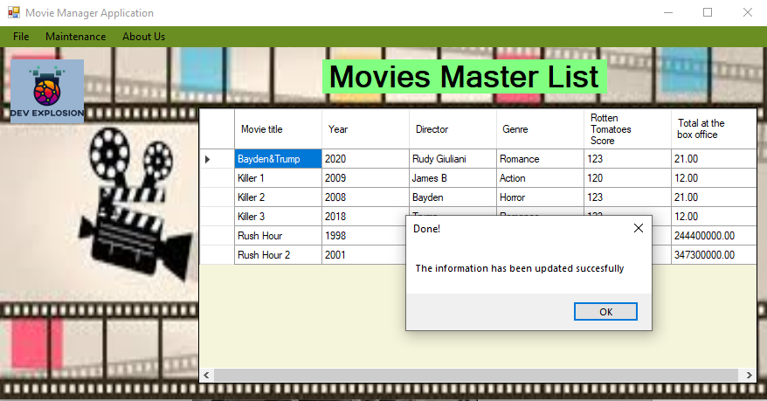

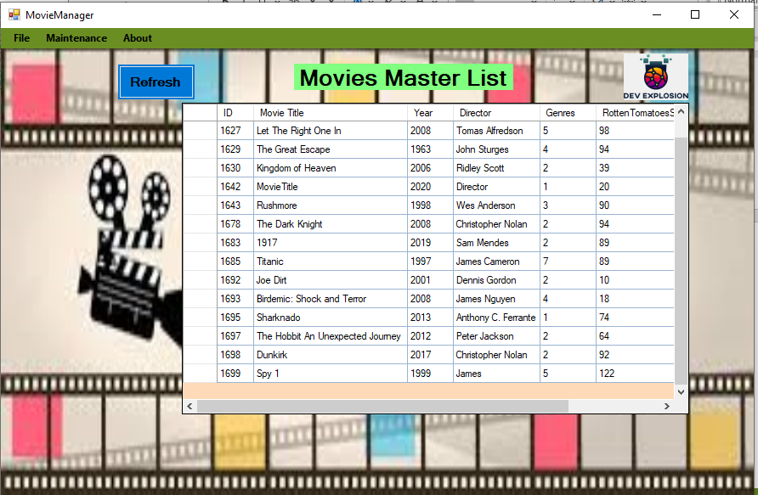

Delete Form

This form enables the super user to delete any movie which would have been wrongly listed

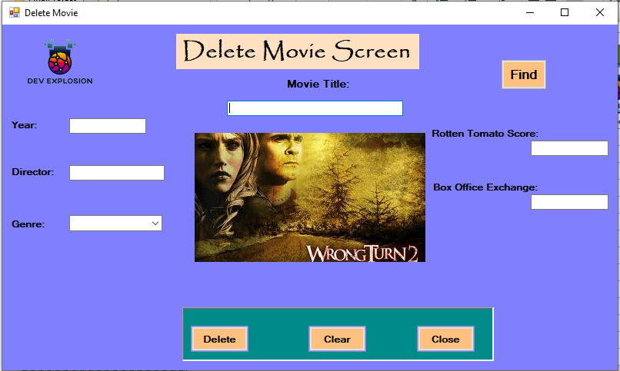

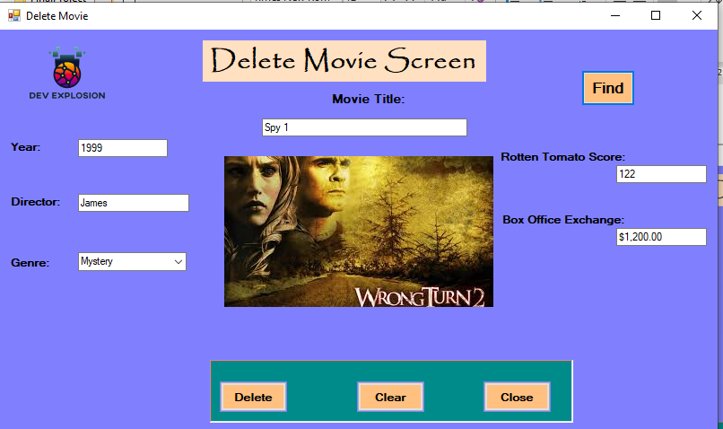

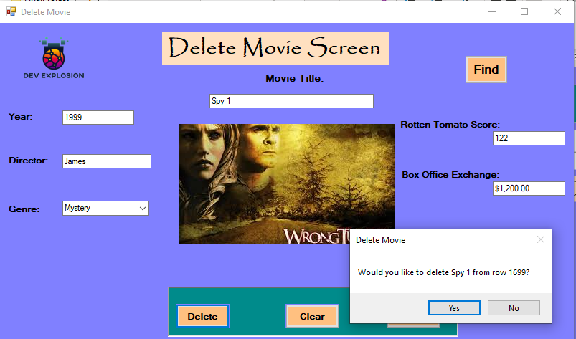

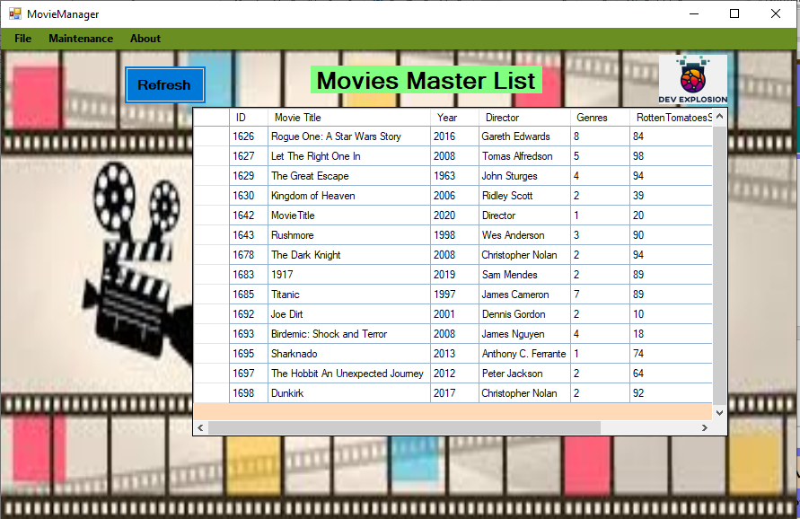

About Form

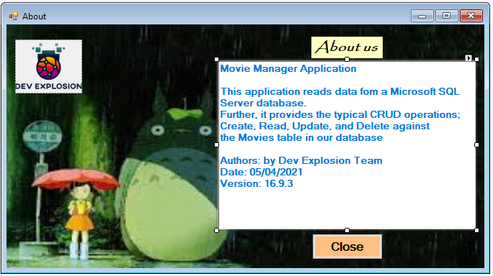

# Roadblocks

During the development period I have encountered numerous roadblock, as a result I had to add extra efforts in to counter them and continue working on the project. Some of the key roadblock includes;

1. Learning and applying c# winform features and controls as well as using Visual Studio for the project development. I had to use online tools and tutorials to work on the project.
2. Other challenges included the cost and time required to deliver on the project.

If I had more time I would have perfected by C# skills and database design skills in order to redesign the application into a more realistic system with more interconnections.

# References

Ortega-Mendoza, A. (2021). Biggest Challenges Faced as a Project Manager. Retrieved 4 May 2021, from <https://www.projectinsight.net/blogs/project-management/biggest-challenges-faced-as-a-project-manager>

Wysocki, R. (2013). Effective Project Management. Wiley.